ASIA PACIFIC SUBMARINE CONFERENCE (APSC) 2016
INDUSTRY RECEPTION
FREMANTLE, W. AUSTRALIA

Asia-Pacific Submarine Conference (APSC) brings together regional submarine operating navies, and other navies with an interest in submarine safety, to discuss issues on submarine survivability, escape and interoperability of rescue assets. APSC helps to foster mutual understanding and cooperation, and is an important knowledge exchange platform for all participants.

Sonistics will be co-ordinating an Industry Reception as part of the ASPC and invite key companies to participate.

Final details are still being discussed but please put a note in your diary as follows:-

ASPC INDUSTRY RECEPTION:

Wednesday 21 September 2016 18:00 to 22:00 hrs

Venue:
SIRIUS ROOM
Esplanade Hotel Fremantle – By Rydges
Cnr Marine Terrace and Essex Street
Fremantle, WA
Australia

Tel: +61 8 9432 4000
www.rydges.com

Full information will be released shortly but please contact Sam Hopkins to note an interest.

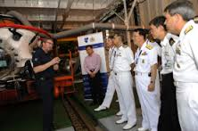
APSC 2015 - Singapore

